LAB ACTIVITY (Lab-08)
1. Banking System with Transactions

Features & Concepts Covered
- Classes
  - Account (base class), SavingsAccount, CurrentAccount (subclasses).
- Constructors
  - Default + Parameterized constructors.
- Inheritance & Overriding
  - SavingsAccount and CurrentAccount override withdraw() with different rules.
- Overloading Methods
  - deposit(int amount) vs deposit(double amount).
- Interfaces
  - Transaction with deposit() and withdraw().
  - Auditable (marker interface).
- Abstract Class
  - BankUser with abstract showDetails().
- Use of this keyword
  - Inside constructors to refer to current object.
- Access Modifiers
  - Private balance, protected methods, public service methods.
- Control Statements
  - if-else for transaction logic.
  - switch for menu-driven program.
  - while/do-while for continuous banking session.
  - break and continue for exiting operations.
- Packages
  - bank.accounts, bank.transactions, bank.users.
- Arrays
  - Store multiple accounts in an array or ArrayList.
- Final Keyword
  - A final constant like MIN_BALANCE = 500.

import java.util.*;

// Abstract class
abstract class BankUser {
protected String name;
protected int accountNumber;

public BankUser(String name, int accountNumber) {
this.name = name;
this.accountNumber = accountNumber;
}

public abstract void showDetails();
}

// Interface
interface Transaction {
void deposit(double amount);
void withdraw(double amount);
}

// Marker interface
interface Auditable { }

// Base Account class
class Account extends BankUser implements Transaction, Auditable {
protected double balance;
protected static final double MIN_BALANCE = 500.0;

public Account(String name, int accountNumber, double balance) {
super(name, accountNumber);
this.balance = balance;
}

// Overloading deposit()
public void deposit(int amount) {
deposit((double) amount);
}

@Override
public void deposit(double amount) {
this.balance += amount;
System.out.println("Deposited: " + amount);
}

@Override
public void withdraw(double amount) {
if (balance - amount >= MIN_BALANCE) {
balance -= amount;
System.out.println("Withdrawn: " + amount);
} else {
System.out.println("Insufficient balance! Minimum balance must be maintained.");
}
}

@Override
public void showDetails() {
System.out.println("Account Holder: " + name);
System.out.println("Account Number: " + accountNumber);
System.out.println("Balance: " + balance);
}
}

// SavingsAccount inherits from Account
class SavingsAccount extends Account {
public SavingsAccount(String name, int accountNumber, double balance) {
super(name, accountNumber, balance);
}

@Override
public void withdraw(double amount) {
System.out.println("Savings Account Withdrawal:");
super.withdraw(amount);
}
}

// CurrentAccount inherits from Account
class CurrentAccount extends Account {
private static final double OVERDRAFT_LIMIT = -1000.0;

public CurrentAccount(String name, int accountNumber, double balance) {
super(name, accountNumber, balance);
}

@Override
public void withdraw(double amount) {
if (balance - amount >= OVERDRAFT_LIMIT) {
balance -= amount;
System.out.println("Withdrawn: " + amount);
} else {
System.out.println("Overdraft limit exceeded!");
}
}
}

// Main menu-driven program
public class BankingSystem {
public static void main(String[] args) {
Scanner sc = new Scanner(System.in);
ArrayList<Account> accounts = new ArrayList<>();
int choice;

do {
System.out.println("\n=== Banking System Menu ===");
System.out.println("1. Create Savings Account");
System.out.println("2. Create Current Account");
System.out.println("3. Deposit");
System.out.println("4. Withdraw");
System.out.println("5. Show Account Details");
System.out.println("6. Search Account by Name");
System.out.println("7. Exit");
System.out.print("Enter choice: ");
choice = sc.nextInt();

switch (choice) {
case 1:
System.out.print("Enter Name: ");
sc.nextLine();
String sName = sc.nextLine();
System.out.print("Enter Account Number: ");
int sAccNo = sc.nextInt();
System.out.print("Enter Initial Balance: ");
double sBal = sc.nextDouble();
accounts.add(new SavingsAccount(sName, sAccNo, sBal));
System.out.println("Savings Account Created!");
break;

case 2:
System.out.print("Enter Name: ");
sc.nextLine();
String cName = sc.nextLine();
System.out.print("Enter Account Number: ");
int cAccNo = sc.nextInt();
System.out.print("Enter Initial Balance: ");
double cBal = sc.nextDouble();
accounts.add(new CurrentAccount(cName, cAccNo, cBal));
System.out.println("Current Account Created!");
break;

case 3:
System.out.print("Enter Account Number: ");
int dAccNo = sc.nextInt();
for (Account acc : accounts) {
if (acc.accountNumber == dAccNo) {
System.out.print("Enter Deposit Amount: ");
double damt = sc.nextDouble();
acc.deposit(damt);
}
}
break;

case 4:
System.out.print("Enter Account Number: ");
int wAccNo = sc.nextInt();
for (Account acc : accounts) {
if (acc.accountNumber == wAccNo) {
System.out.print("Enter Withdraw Amount: ");
double wamt = sc.nextDouble();
acc.withdraw(wamt);
}
}
break;

case 5:
System.out.print("Enter Account Number: ");
int sAccDetails = sc.nextInt();
for (Account acc : accounts) {
if (acc.accountNumber == sAccDetails) {
acc.showDetails();
}
}
break;

case 6:
System.out.print("Enter Name to Search: ");
sc.nextLine();
String searchName = sc.nextLine();
boolean found = false;
for (Account acc : accounts) {
if (acc.name.equalsIgnoreCase(searchName)) {
acc.showDetails();
found = true;
}
}
if (!found) {
System.out.println("No account found with the name: " + searchName);
}
break;

case 7:
System.out.println("Exiting... Thank you!");
break;

default:
System.out.println("Invalid choice!");
}
} while (choice != 7);

sc.close();
}
}

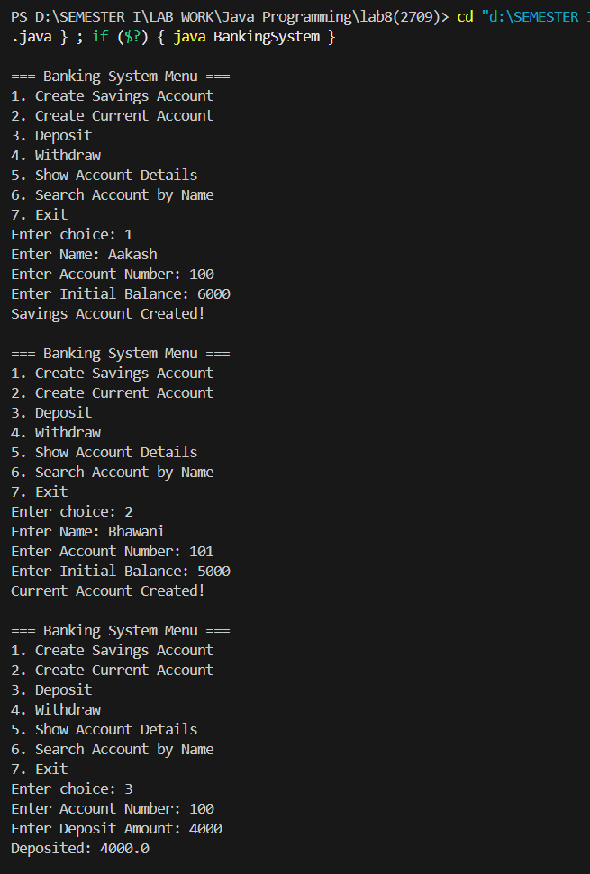

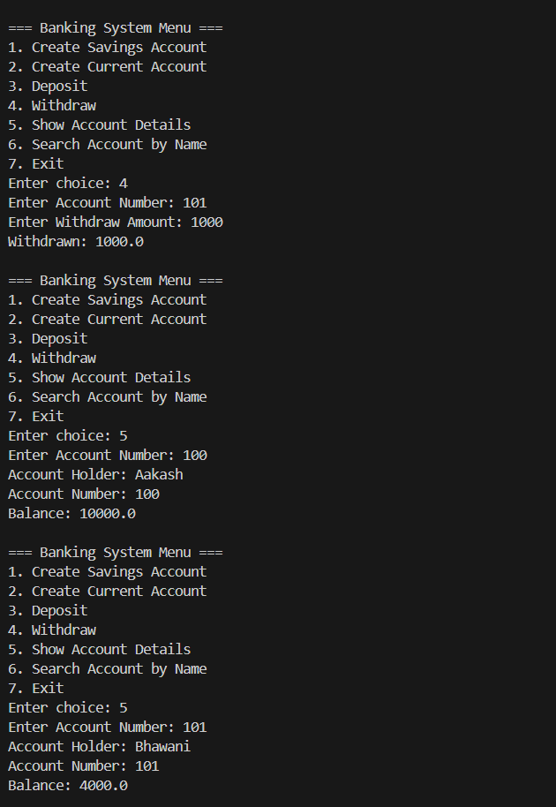

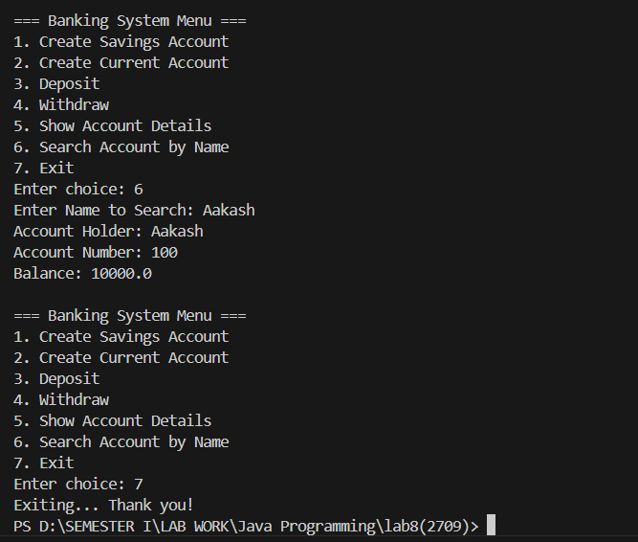

2. University Management System
- Abstract class → Person
- Inheritance & Overriding → Student, Professor
- Interfaces → Enrollable
- Marker interface (in Banking System project)
- Constructors (default + parameterized)
- this keyword (inside constructors)
- Access Modifiers (private, protected, public)
- Final class with constants → UniversityConstants
- Control statements (switch, if-else, loops, break, continue)
- Arrays/ArrayLists for object storage
- Menu-driven program

import java.util.*;

// Abstract class
abstract class Person {
protected String name;
protected int id;

public Person() {
this("Unknown", 0);
}

public Person(String name, int id) {
this.name = name;
this.id = id;
}

public abstract void showDetails();
}

// Interface
interface Enrollable {
void enroll(String course);
}

// Marker interface for University Management System
interface UniversityMember {}

// Final class with constants
final class UniversityConstants {
public static final String UNIVERSITY_NAME = "ABC University";
public static final int MAX_COURSES = 5;
private UniversityConstants() {}
}

// Student class
class Student extends Person implements Enrollable, UniversityMember {
private ArrayList<String> courses;

public Student() {
this("Unknown Student", 0);
}

public Student(String name, int id) {
super(name, id);
this.courses = new ArrayList<>();
}

@Override
public void enroll(String course) {
if (courses.size() < UniversityConstants.MAX_COURSES) {
courses.add(course);
System.out.println(name + " enrolled in " + course);
} else {
System.out.println("Cannot enroll in more than " + UniversityConstants.MAX_COURSES + " courses.");
}
}

@Override
public void showDetails() {
System.out.println("Student Name: " + name);
System.out.println("Student ID: " + id);
System.out.println("Courses: " + courses);
}
}

// Professor class
class Professor extends Person implements Enrollable, UniversityMember {
private String department;
private ArrayList<String> courses;

public Professor() {
this("Unknown Professor", 0, "Unknown");
}

public Professor(String name, int id, String department) {
super(name, id);
this.department = department;
this.courses = new ArrayList<>();
}

@Override
public void enroll(String course) {
courses.add(course);
System.out.println(name + " assigned to teach " + course);
}

@Override
public void showDetails() {
System.out.println("Professor Name: " + name);
System.out.println("Professor ID: " + id);
System.out.println("Department: " + department);
System.out.println("Courses Teaching: " + courses);
}
}

public class UniversityManagement {
public static void main(String[] args) {
Scanner sc = new Scanner(System.in);
ArrayList<Person> people = new ArrayList<>();
int choice;
do {
System.out.println("\n=== " + UniversityConstants.UNIVERSITY_NAME + " Management System ===");
System.out.println("1. Add Student");
System.out.println("2. Add Professor");
System.out.println("3. Enroll Student in Course");
System.out.println("4. Assign Course to Professor");
System.out.println("5. Show Person Details");
System.out.println("6. List All People");
System.out.println("7. Exit");
System.out.print("Enter choice: ");
choice = sc.nextInt();
sc.nextLine();

switch (choice) {
case 1: // Add Student
System.out.print("Enter Student Name: ");
String sName = sc.nextLine();
System.out.print("Enter Student ID: ");
int sId = sc.nextInt();
sc.nextLine();
people.add(new Student(sName, sId));
System.out.println("Student added.");
break;
case 2: // Add Professor
System.out.print("Enter Professor Name: ");
String pName = sc.nextLine();
System.out.print("Enter Professor ID: ");
int pId = sc.nextInt();
sc.nextLine();
System.out.print("Enter Department: ");
String dept = sc.nextLine();
people.add(new Professor(pName, pId, dept));
System.out.println("Professor added.");
break;
case 3: // Enroll Student
System.out.print("Enter Student ID: ");
int esId = sc.nextInt();
sc.nextLine();
boolean foundStudent = false;
for (Person p : people) {
if (p instanceof Student && p.id == esId) {
System.out.print("Enter Course to Enroll: ");
String course = sc.nextLine();
((Enrollable)p).enroll(course);
foundStudent = true;
break;
}
}
if (!foundStudent) {
System.out.println("Student not found.");
}
break;
case 4: // Assign Course to Professor
System.out.print("Enter Professor ID: ");
int epId = sc.nextInt();
sc.nextLine();
boolean foundProf = false;
for (Person p : people) {
if (p instanceof Professor && p.id == epId) {
System.out.print("Enter Course to Assign: ");
String course = sc.nextLine();
((Enrollable)p).enroll(course);
foundProf = true;
break;
}
}
if (!foundProf) {
System.out.println("Professor not found.");
}
break;
case 5: // Show Person Details
System.out.print("Enter Person ID: ");
int pid = sc.nextInt();
sc.nextLine();
boolean found = false;
for (Person p : people) {
if (p.id == pid) {
p.showDetails();
found = true;
break;
}
}
if (!found) {
System.out.println("Person not found.");
}
break;
case 6: // List All People
if (people.isEmpty()) {
System.out.println("No people in the system.");
break;
}
for (Person p : people) {
p.showDetails();
System.out.println("-------------------");
}
break;
case 7:
System.out.println("Exiting... Thank you!");
break;
default:
System.out.println("Invalid choice!");
}
} while (choice != 7);
sc.close();
}
}

